Name _____________________________________________________________________________
-un word family
Directions: Choose a bun. Color it appropriately. Write the word for the picture that is on the bun. All words will end with -un.

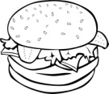
- ________________________ 4. ___________________________

- _________________________ 5. ___________________________

- _________________________ 6. ___________________________

Choose 1 –un word and write a sentence.
__________________________________________________________________________________
__________________________________________________________________________________

